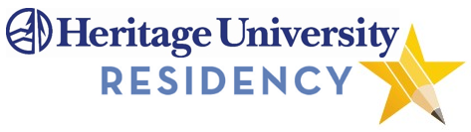

Description of Program - In the HU Accelerate program is one of the fastest routes to earning your Master in teaching and teaching certification. If you have a Bachelors degree, you can earn your degree in 11 months while working as a mentored resident intern (student teacher) in a K-8 classroom two or three days each week. The other days during the week, you will have the opportunity to be paid as a Para educator or substitute teacher. At the end of the program you will graduate with your Master in Teaching degree, WA State Teaching Certificate with an endorsement in K-8 education and an endorsement in English Language Learners, Bilingual Education or Special Education.

Location and Course Scheduling – This program is offered from our Toppenish Campus and our satellite campus at Columbia Basin College in the Tri-Cities. The program starts in June with a 6 week intensive Summer Institute. Classes during the summer take place M-F from 8:00am to 5:00pm. Fall and Spring Semester coursework is scheduled Friday evening from 5:30pm -8:30pm and 8:00am-5:00pm Saturday two weekends a month.

Delivery Method – The course is a hybrid online and face-to-face delivery method.

Prerequisites – A Bachelors degree and passing scores on the WEST-B and NES tests.

For Further Information Contact:

SHARI FOSTER
Graduate Program Coordinator
Foster_S@heritage.edu (509) 865-8623
-or-
CollegeofEd@heritage.edu (509) 865-8650

