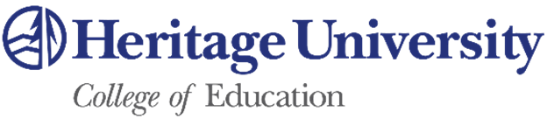

Master in Teaching – Accelerate Program (State Route #4)

Description of Program - The HU Accelerate program is one of the fastest routes to earning your Master in Teaching and teaching certification. If you have a Bachelor degree, you can earn your degree in 11 months while working as a paid, full-time teacher in a K-8 classroom. The program is challenging, but upon graduating, you will have a year of experience managing your own classroom along with your degree and certifications. At the end of the program, you will graduate with your Master in Teaching degree, WA State Teaching Certificate with an endorsement in K-8 education and an endorsement in English Language Learners, Bilingual Education or Special Education.

Location and Course Scheduling – This program is offered from our Toppenish Campus and our satellite campus at Columbia Basin College in the Tri-Cities. The program starts in June a 10 week intensive Summer Institute. Classes during the summer take place M-F from 8:30am to 1:45pm. Fall and Spring Semester coursework is scheduled Friday evening from 5:30pm -9:00pm and 8:00am-5:00pm Saturday two weekends a month.

Delivery Method – The course is available in a face-to-face delivery method* (or hybrid face to face and synchronous online), synchronous online, or asynchronous online.

Prerequisites – A Bachelor degree with a 3.0 or adequate evidence of academic success in your last 30-45 credits and completion of the WEST-B (or sufficient scores on the SAT or ACT) and NES tests.

For Further Information Contact: CollegeofEd@heritage.edu (509) 865-8650 or Shari Foster, Graduate Program Coordinator, Foster_S@heritage.edu , (509) 941-2462.

